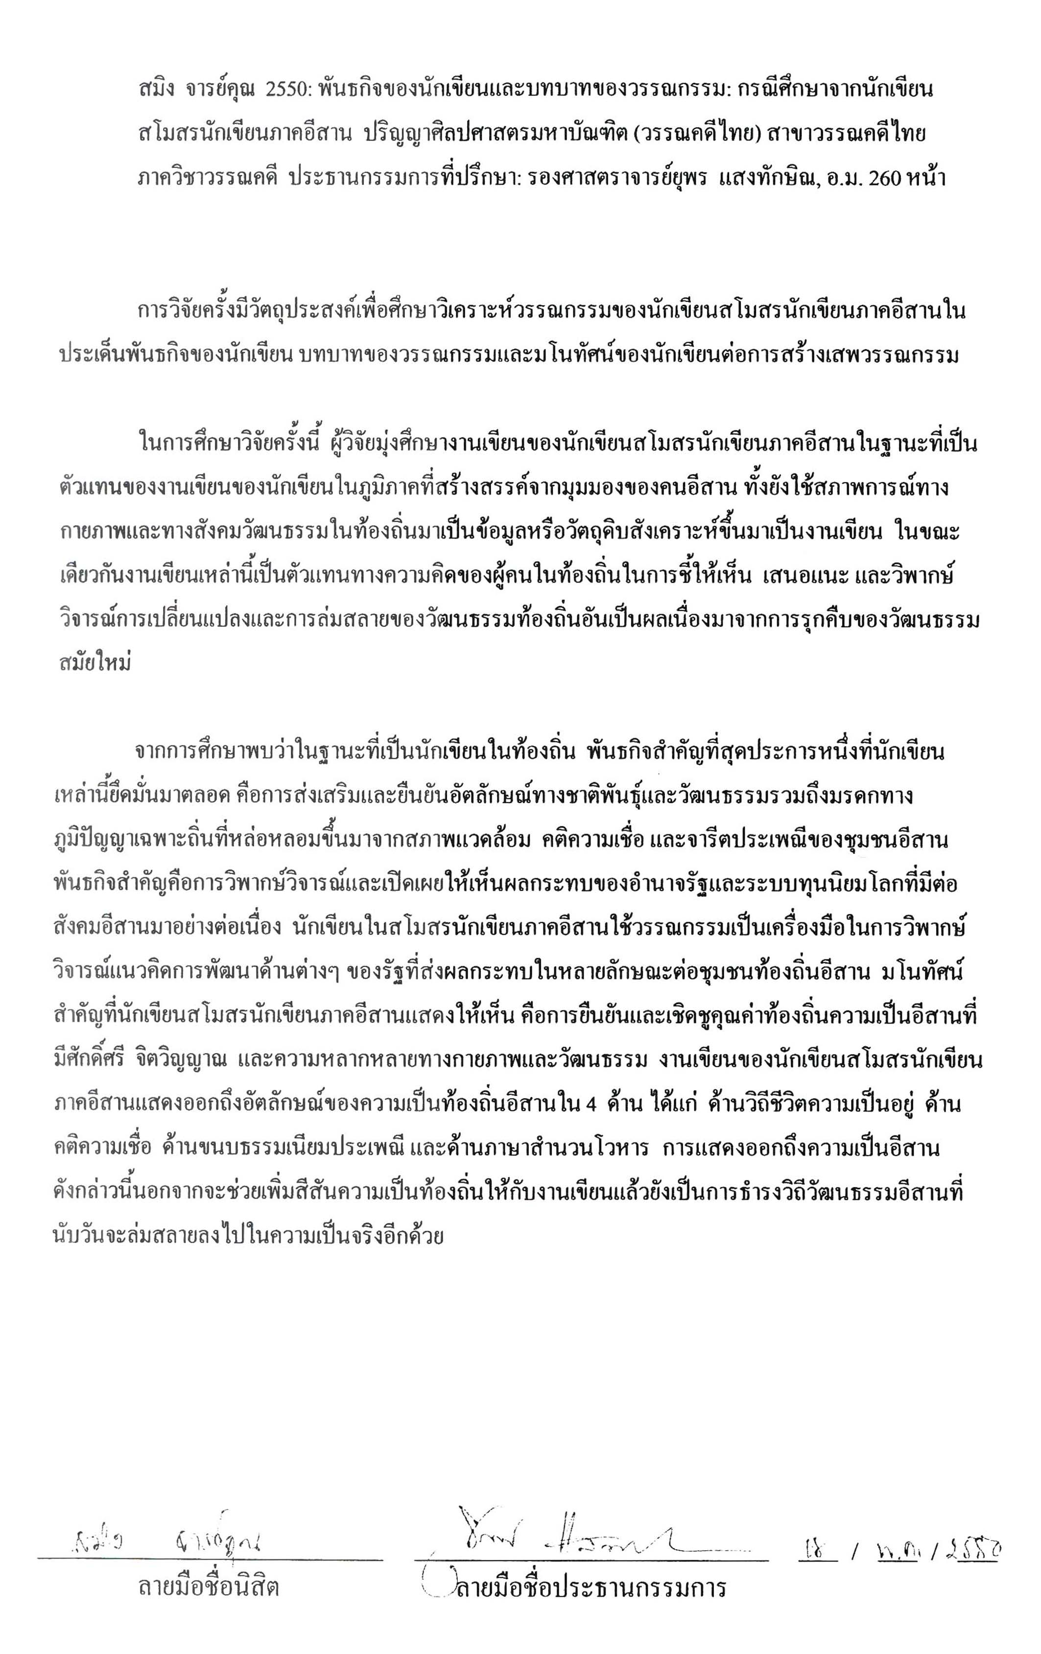
Saming Chankoon 2007: The Mission of the Writers and the Role of Literary Works:
A Case Study of Esan Writers’ Club. Master of Arts (Thai Literature), Major Field: Thai Literature, Department of Literature. Thesis Advisor:
Associate Professor Yuporn Sangtaksin, M.A. 260 pages.

The objective of this research is to make an analytical study of literary works by Thailand’s Northeastern writers in terms of the writers’ missions, the role of literary works, and the writers’ concepts in their creation and reception of literary works.

In this research, the focus is on the writings of the Esan Writers’ Club members, as representative of literary works by Northeastern writers who write from regional viewpoints, basing on local settings and cultures. These works, in turn, represent local people’s ideas in pointing out and commenting on the changes and deterioration caused to local culture by the invading modern one.

The study has found that one of the most significant missions taken hold of by these writers, as natives of the Northeastern region, is to insist on and to cherish their ethnic and cultural identities, including their cultural heritage – the wisdom formed by local environment, beliefs, customs, and traditions. The other significant mission is to make comment on and to reveal, through their writings, the continuing destructive effects on various aspects of Northeastern society caused by state authority’ s developing schemes as well as global capitalism . The main concepts presented are the insistence on and the cherish of the regional values, dignity and spirit, which consist in geographical and cultural varieties. There are four aspects of Northeastern identities depicted: life style, belief, tradition, and language. These identities do not only contribute to the writings ‘local color,’ but also help to keep alive local culture which is actually dying.

 |  |  |  |  | /
Student’s signature |  | Thesis Advisor’s signature

